# Tables and Graphing

**AIM: To find if having a longer foot will cause a person to have a larger arm span.**

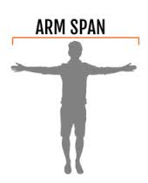

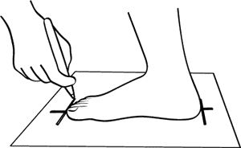

**What is the independent variable? (Which variable do we think is causing something to happen?)**

**What is the dependent variable? (Which variable do we think is being affected by the change?)**

|  |  |
| --- | --- |
| Independent Variable: | Dependent Variable : |
|  |  |
|  |  |
|  |  |
|  |  |
|  |  |

**Table:**

**Put in headings! Then measure and add results.**

**Graph:**

**Remember to include:**

1. **Title Ο (tick when complete)**
2. **Independent on bottom axis Ο (tick when complete)**
3. **Labels and units Ο (tick when complete)**
4. **Good scale along axes Ο (tick when complete)**
5. **Points from table Ο (tick when complete)**
6. **Line of best fit Ο (tick when complete)**

You probably also need a scale break. Find out what this is from your teacher.

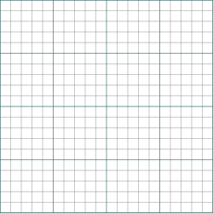

**Conclusion:**

Does your graph give a shape that suggests there is a relationship between your variables?